

**Virtual Art Gallery**

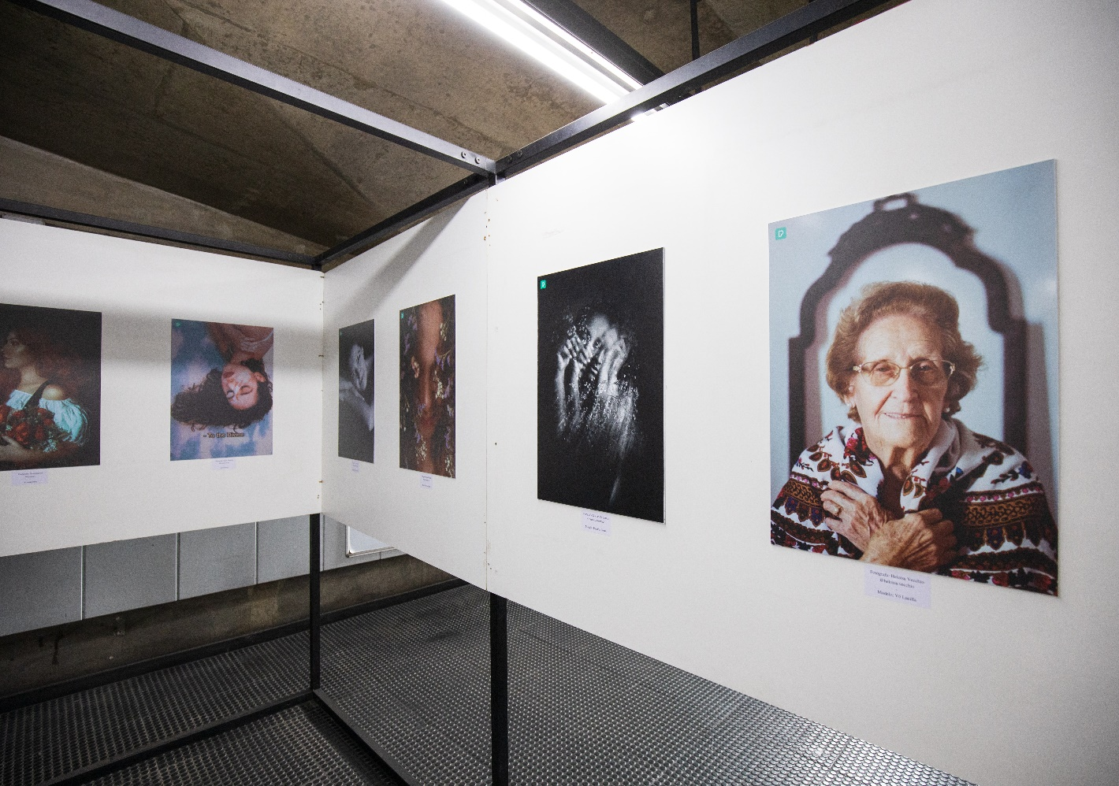

Student: Hishmat Malhani

Project Name: Virtual Art Gallery

Subject: DSA lab

Teacher: Fozia Khan

**Problem statement**

The main purpose of this project was to design and implement a virtual reality gallery application that allows users to experience an immersive art exhibition from the comfort of their own space. The application should provide an engaging interface to explore a collection of artworks, search for specific pieces, and enjoy a lifelike gallery environment using VR technology.

**Project Features:**

The virtual reality gallery project aims to create an interactive and realistic art gallery experience for users. The project encompasses the following key features:

**Artwork Management:**

Users can view and explore a diverse collection of artworks, each identified by an ID, title, artist, and additional attributes.Artworks should be categorized and organized based on criteria such as artist, style, era, and medium.

**Virtual Gallery Environment:**

Implement a virtual reality environment that simulates a gallery space. Users should be able to navigate within the gallery, move closer to artworks for detailed views, and interact with the surroundings.

**User Interaction:**

Users can interact with artworks by selecting them for closer inspection. Implement user-friendly navigation controls for moving around the virtual space and selecting artworks.

**Artwork Search and Display:**

Provide a search feature that enables users to find artworks by title, artist, style, or any other relevant attribute. Display search results with the option to select and view the matching artworks.

**Sorting and Filtering:**

Allow users to sort artworks based on various attributes such as artist, style, or date. Implement a filtering mechanism to narrow down paintings based on user preferences.

**User Profiles and Preferences:**

Users can create profiles with personalized settings and preferences. Preferences might include favorite artists, preferred styles, and previous interactions.

**Data Persistence:**

Implement data storage and retrieval mechanisms to save and load artworks, user profiles, and preferences.

Possible classes

1. Artwork
2. VirtualGallery
3. User
4. GalleryDisplay
5. SearchEngine
6. SortManager
7. UserInterface
8. FileHandler
9. EventManager
10. GalleryManager

**Data structures for temporary storage you will use and why?**

Well following data structures, I will use them in my virtual art gallery project.

**Vector:**

Vectors are dynamic arrays that provide constant-time random access and fast insertion/removal at the end. They are suitable for storing a collection of artworks or other data that needs to be quickly accessed and modified.

**Map:**

Maps provide a key-value pairing, allowing you to associate each artwork's ID with its corresponding object. This can make searching and retrieval by ID efficient. If the order of retrieval is not critical, an unordered map can offer faster average lookups.

**Linked List:**

Linked lists allow for efficient insertions and deletions at any position in the list. If you anticipate frequent insertions or removals within the collection of artworks, a linked list could be considered.

**Queue:**

If you need to manage a queue of events, interactions, or scheduled tasks within the gallery, a queue or priority queue can help maintain the order of execution.

**Stack:**

For managing actions or interactions that follow a last-in, first-out (LIFO) order, a stack could be useful. This might include keeping track of the user's navigation history or interactions with artworks.

**Deque:**

A deque (double-ended queue) combines the advantages of vectors and linked lists. It provides fast insertion and deletion at both ends of the collection, making it suitable for scenarios where you need efficient manipulation at the front and back.

Sorting and searching algorithms you will use and why?

**Sorting Algorithms:**

**Quick Sort:**

Quick Sort is a widely used sorting algorithm known for its efficiency and relatively simple implementation. It offers average-case time complexity of O (n log n), making it suitable for sorting a large number of artworks. It's particularly well-suited I need to sort based on attributes like artist names.

**Merge Sort:**

Merge sort also has an average-case time complexity of O (n log n). It's a stable sorting algorithm that works well for large datasets and is suitable when memory usage is not a concern.

**Sort (C++ Standard Library Sort):**

The Sort function provided by the C++ Standard Library is a highly optimized sorting algorithm that adapts to the data and performs well in practice. It's a good choice for general-purpose sorting tasks.

**Searching Algorithms:**

**Binary Search:**

Binary search offers efficient O (log n) time complexity for finding a specific artwork by its ID or title. It's especially useful when you have a large dataset and want to quickly locate specific items.

**Linear Search:**

Linear search has a worst-case time complexity of O(n), making it suitable for smaller datasets. It's straightforward to implement and can be used for searching if the collection is not sorted.

**Hashing (Using Hash Maps):**

Hashing allows for O (1) average-case search time in hash maps or unordered maps. If you need to search by artwork ID frequently and the IDs are unique, hashing can provide efficient retrieval.

**Motivation and Background of the Project**:

let's talk about why I am diving into the "Virtual Reality Gallery" project. You know, it all starts with that feeling that art can sometimes be a bit out of reach – you have to travel, maybe wait in lines, and often it's not so feasible to just pop into an art gallery whenever you want. But hey, technology is opening up new doors, and that's where the idea came in. I thought, "What if I could bring the art gallery experience to you, wherever you are?"

Think about it: traditional galleries are great, but they have their limits. There's only so much time in a day, and not everyone can hop around the globe to see all the art they'd like. So, here's where virtual reality comes in. I am taking the best of both worlds – art, and technology – to give you a way to explore artworks like never before.

Behind the scenes, the whole thing is rooted in this mix of art appreciation and the power of VR tech. I am not the first to think of it, but I am aiming to create an experience that's not just about clicking through images on a screen. I want you to feel like you're walking through an actual gallery, with artworks hanging on walls, waiting for you to discover. This project taps into the excitement of exploring art in new ways, all from the comfort of your own space. And you know what? This project isn't just a random idea. It's a response to the way technology is changing things. Virtual reality isn't just for gamers – it's breaking into different parts of our lives, and art is no exception. The cool part is that VR gear is getting better and more accessible, which means we can create this virtual world that feels real, like stepping into a new dimension where art is all around you.

In the end, I would say, this "Virtual Reality Gallery" project isn't just about pretty visuals and fancy tech. It's about making art more accessible, giving you a chance to explore and connect with art in a way that fits into your life. It's about taking that feeling of wonder you get when you walk into a gallery and turning it into something you can experience anytime, anywhere. So, get ready to step into a virtual realm where art comes alive, and you're the curator of your gallery adventure.

Thank you😊